|  |  |  |  |  |
| --- | --- | --- | --- | --- |
| **National University of Computer and Emerging Sciences, Lahore Campus** | | | | |
| C:\Users\saif\AppData\Local\Microsoft\Windows\Temporary Internet Files\Content.Word\final design.jpg | **Course:** | **Object Oriented Programming** | **Course Code:** | **CS-1004** |
| **Program:** | **BS (CS,SE,R,DS)** | **Semester:** | **Fall 2023** |
| **Paper Date:** | **20-Feb-24** | **Total Marks:** | **10** |
| **Section:** | **BSSE-4B** | **Duration:** | **10 Minutes** |
| **Exam:** | **Quiz 2** | **Roll No.** |  |
| **Instruction/Notes:** | Attempt all questions. Do not use pencil or red ink. In case of confusion or ambiguity make a reasonable assumption. Do not attach any extra sheet. Use extra sheet for rough work only | | | |

Question 1:

1. Create a table **Person** with following fields

* PersonID varchar (5)
* Name varchar (15)
* Age int
* Gender varchar(5)
* Address varchar(20)

**Constraints.**

* **PersonID** in Person, is primary key. Also apply check constraint for Gender to be Male only.

1. Change the datatype of Gender from varchar(5) to char in **Person** table.

**Question 2.**

**Tbl_Sailor Tbl_Reserve Tbl_Boats**

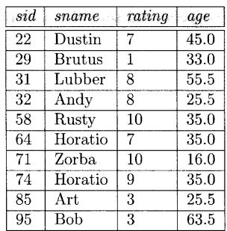 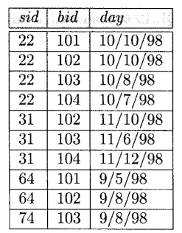 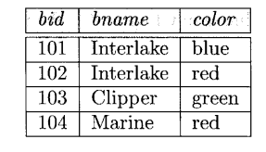

Update the color of boat to Green where The sailor is Lubber and the boat is reserved for ‘11/10/98’

Display all the sailors( who don’t have any reservation) according to rating in desc order.